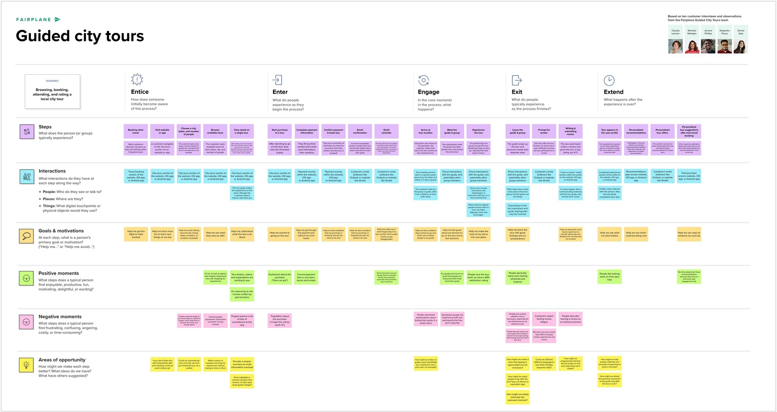

**Hazardous Area Monitoring For Industrial Power plant powered by IoT**

**Scenario Installing the IoT devices ,**

**monitoring and controlling the hazardous area**

Browse the available methods

Compare the available methods

Find IoT is the best one

Install the IoT hardware devices and python software

Seek the IoT expert help

Buy the Cloudant Data Base

With help of Node-red (API) receives the alert message through mobile

Beacon temperature sensors

python script

Arduino or Raspberry pi

Web User Interface (UI)

IBM Watson IoT platform

MS (QR)

Fast2S

|  |  |  |  |  |  |  |  |  |  |  |  |  |
| --- | --- | --- | --- | --- | --- | --- | --- | --- | --- | --- | --- | --- |
|  | Help me to send and store huge amount of data |  | Help me to get Seamless coverage |  | Help me with system Security and scalability |  | Help me for wireless connectivity |  | Help me to avoid high cost |  | Help me to achieve accuracy |  |

Automatic monitoring

Time saving

Simple and easy to implement

Portable and handy

Heating of hardware components

Power consumption

some IoT devices are difficult to address them uniquely

Security

some suggested monitoring using embedded systems

what if there is no internet connectivityY

could it offer workers safetyY